**ID: 19BCA063**

**SHIVAM USTURGE**

Smt. Chandaben Mohanbhai Patel Institute of Computer Applications

Sub: CA314: Object Oriented Programming through JAVA

Practical Assignment-1

Introduction to Java

Q.1 Write a java code to find the factorial of a given number.

package cmpica;

class factorial

{

public void getfact(int num)

{

int fact=1;

for(int i=1;i<=num;i++)

{

fact=fact*i;

}

System.out.println("Factoral of " +num +" is " +fact );

}

}

public class FactQ1

{

public static void main(String[] args) {

factorial f= new factorial();

f.getfact(5);

}

}

OUTPUT:

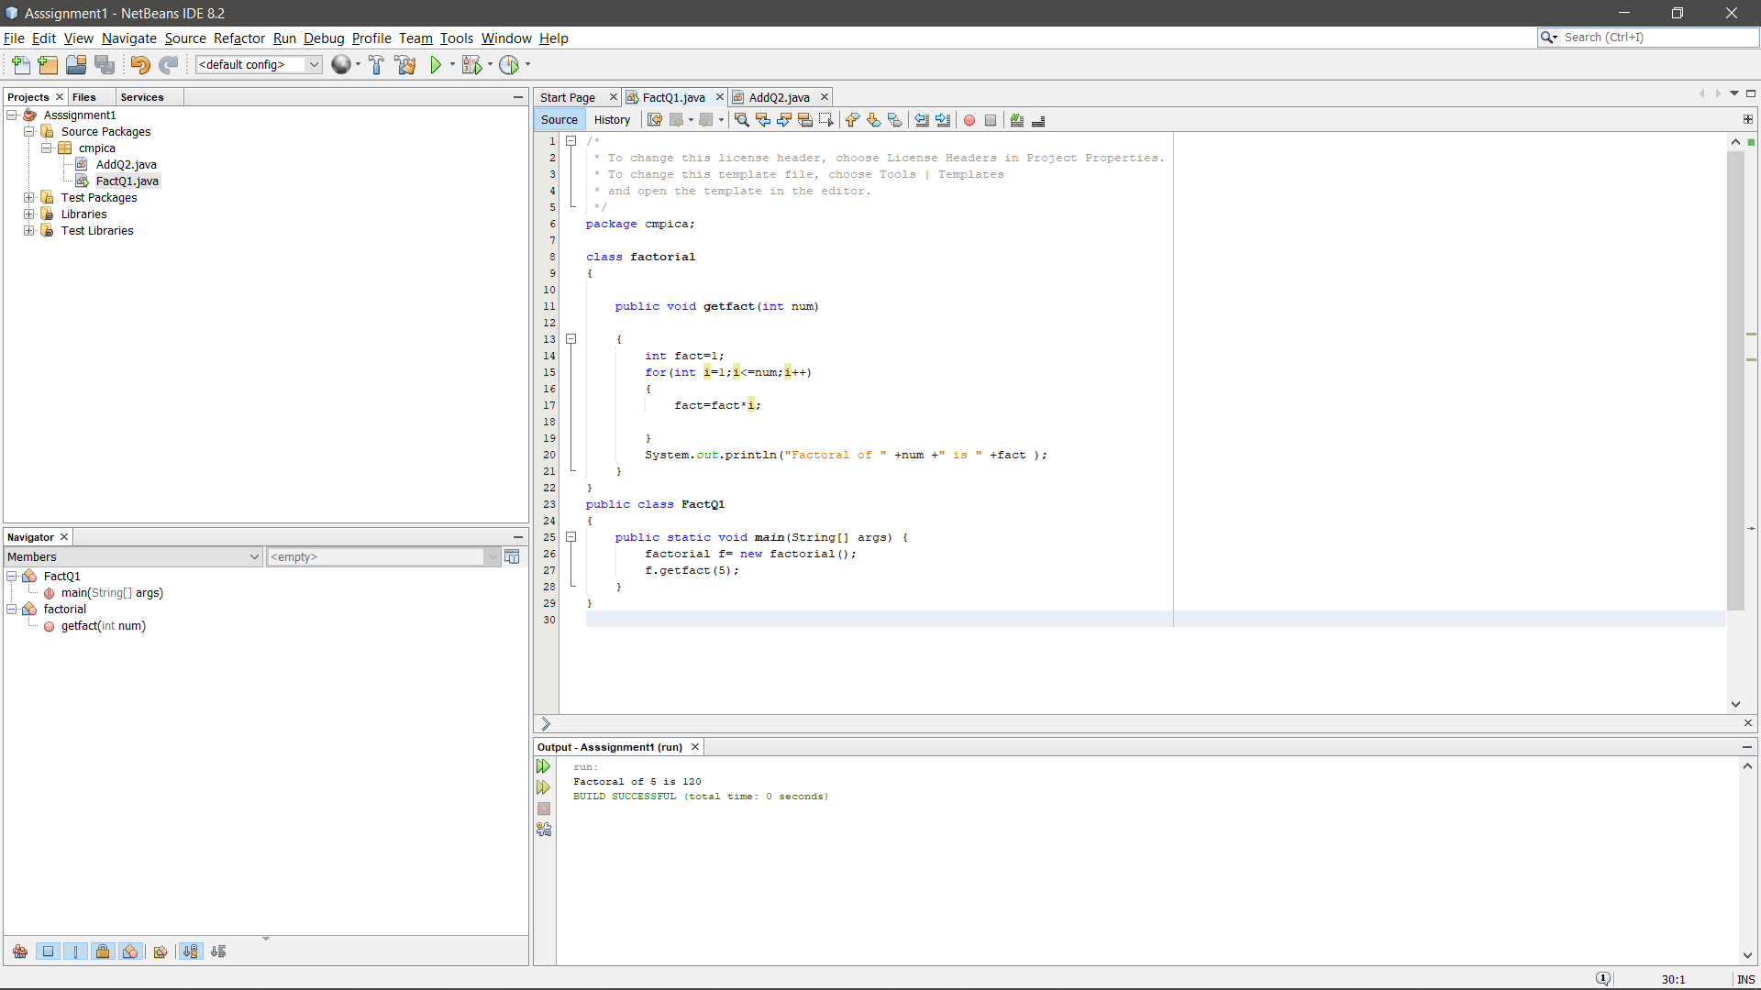

Q.2 Write a code to add the digits of a given number.

package cmpica;

class addition

{

public void getadd(int n)

{

int sum=0,temp,digit;

temp=n;

while (n>0)

{

digit= n%10;

sum=sum+digit;

n= n/10;

}

System.out.println("Sum of Digit Of "+temp+ " is: "+sum);

}

}

public class AddQ2 {

public static void main(String args[]) {

addition a= new addition();

a.getadd(66);

}

}

OUTPUT:

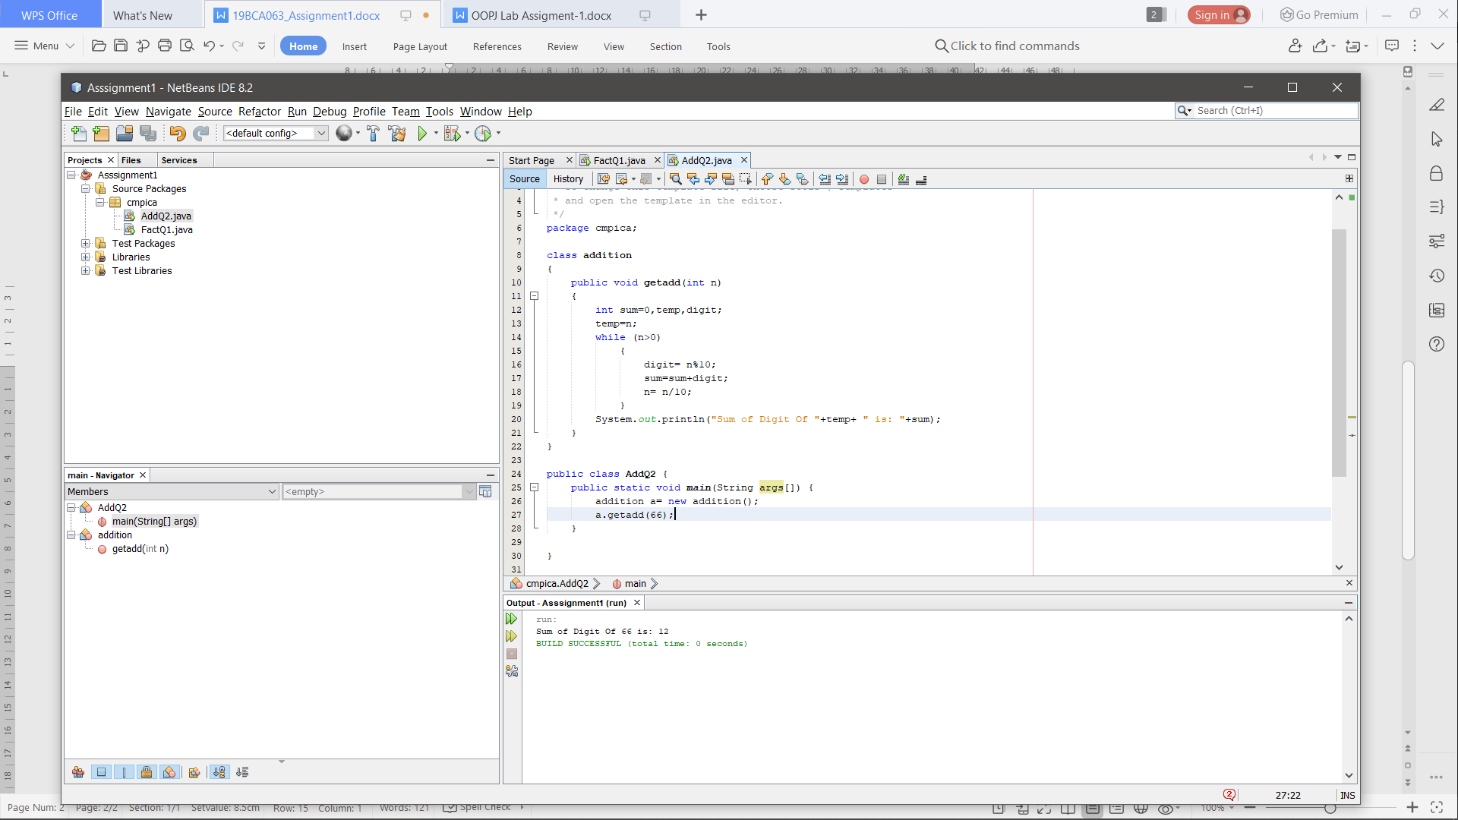

Q.3 Write a code to reverse the digits of a given number Write a code for Swapping of numbers without using third variable.

package cmpica;

class revswap{

public void reverse(int n)

{

int sum=0,r,temp;

temp=n;

while (n>0)

{

r=n%10;

n=n/10;

sum=(sum*10)+r;

}

System.out.println("reverse of "+temp+" is "+sum);

}

public void swap(int n1,int n2)

{

System.out.println("Numbers Before Swapping are: Number1: " +n1+ " Number2: " +n2);

n1=n1+n2;

n2=n1-n2;

n1=n1-n2;

System.out.println("Numbers After Swapping are: Number1: " +n1+ " Number2: " +n2);

}

}

public class revswapQ3 {

public static void main(String args[]) {

revswap r=new revswap();

r.reverse(123);

revswap s=new revswap();

s.swap(10,30);

}

}

OUTPUT:

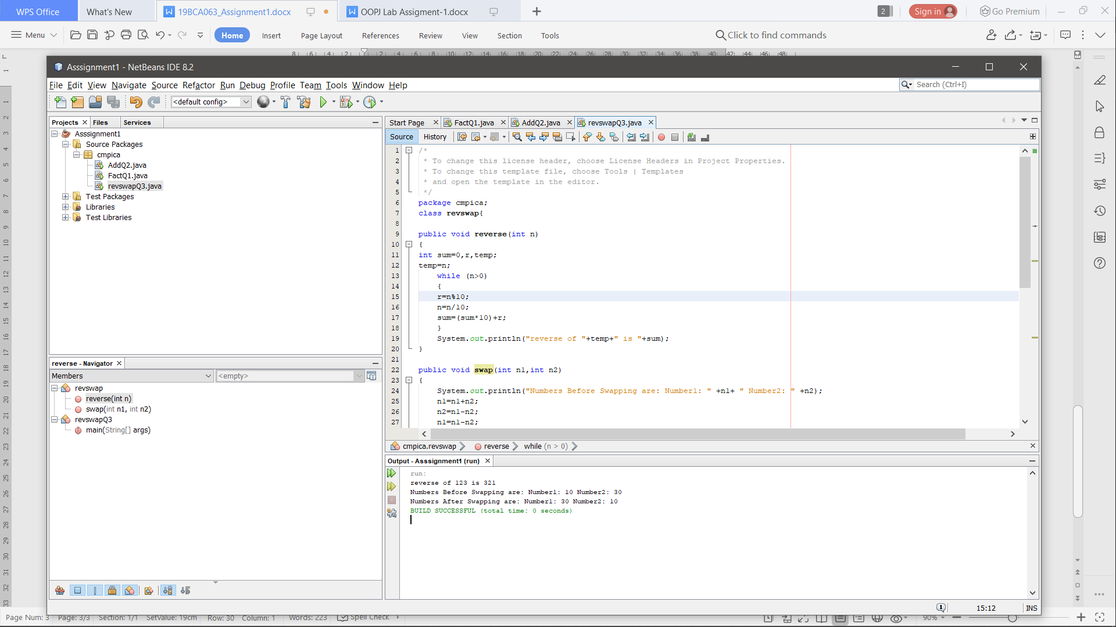

Q.4Write a code to check whether then given number is palindrome or not.

package cmpica;

class palindrome

{

public void getpalindrome(int n)

{

int sum=0,r,temp;

temp=n;

while (n>0)

{

r=n%10;

n=n/10;

sum=(sum*10)+r;

}

if (sum==temp)

System.out.println("Number Is Palindrome");

else

System.out.println("Number Is Not Palindrome");

}

}

public class palindromeQ4

{

public static void main(String[] args)

{

palindrome p= new palindrome();

p.getpalindrome(555);

}

}

OUTPUT:

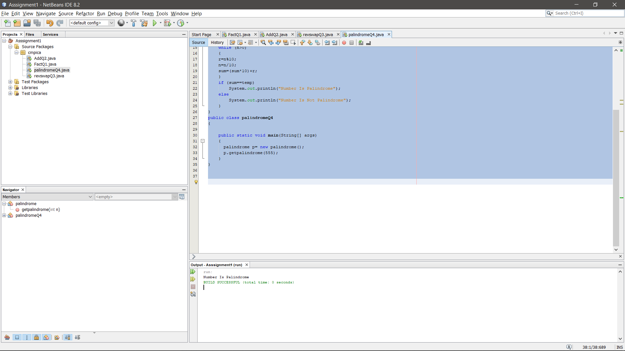

## Q.5 Write a Program to find mean of given numbers in java.

package cmpica;

class mean{

public void getmean(double n1, double n2, double n3)

{

double sum=n1+n2+n3;

double mean=(sum/3.0);

System.out.println("Mean Of 3 Numbers Are: "+mean);

}

}

public class meanQ5 {

public static void main(String args[])

{

mean m=new mean();

m.getmean(12.46, 20.16, 25.40);

}

}

OUTPUT:

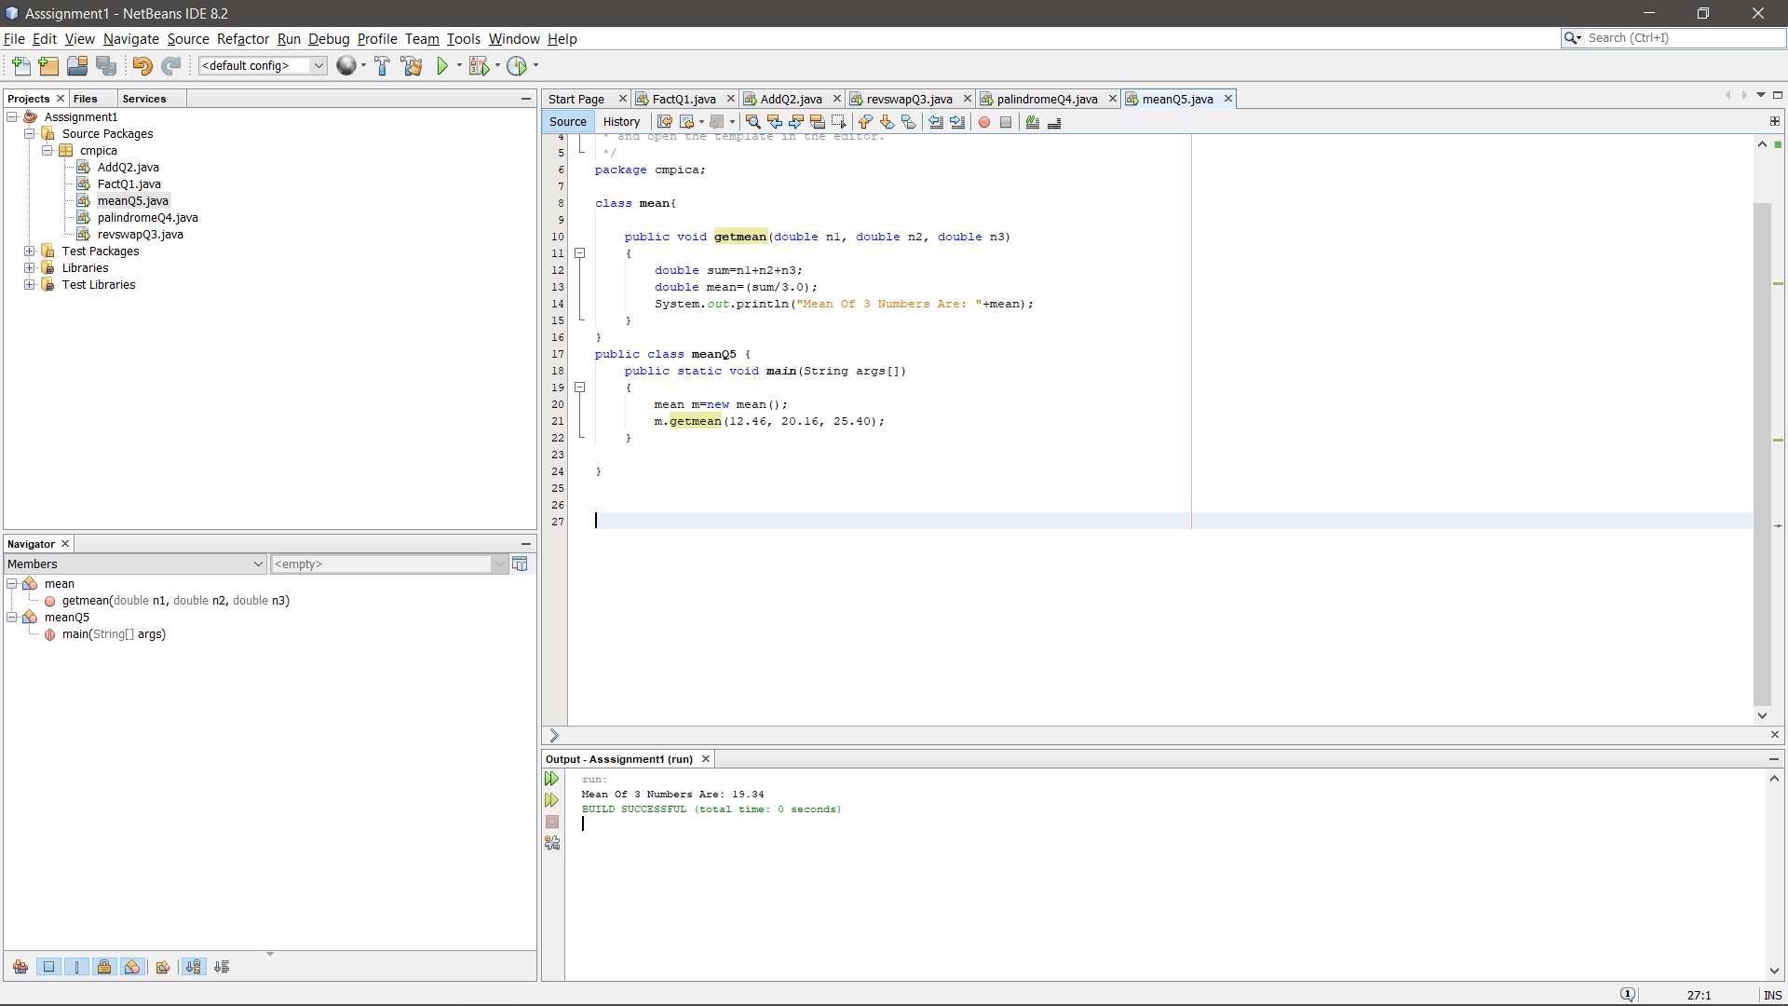

Q.6 Write a program to check whether a given number is Perfect or not from given range.

package cmpica;

class perfect

{

public void checkperfect(int n)

{

int sum=0;

for(int i=1;i<=n;i++)

{

if(n%i==0)

{

sum=sum+i;

}

}

if(sum==n)

{

System.out.println("Given number " +n+ " is Perfect");

}

else

{

System.out.println("Given number " +n+" is not Perfect");

}

}

}

public class perfectQ6 {

public static void main(String args[])

{

perfect p=new perfect();

p.checkperfect(6);

}

}

OUTPUT:

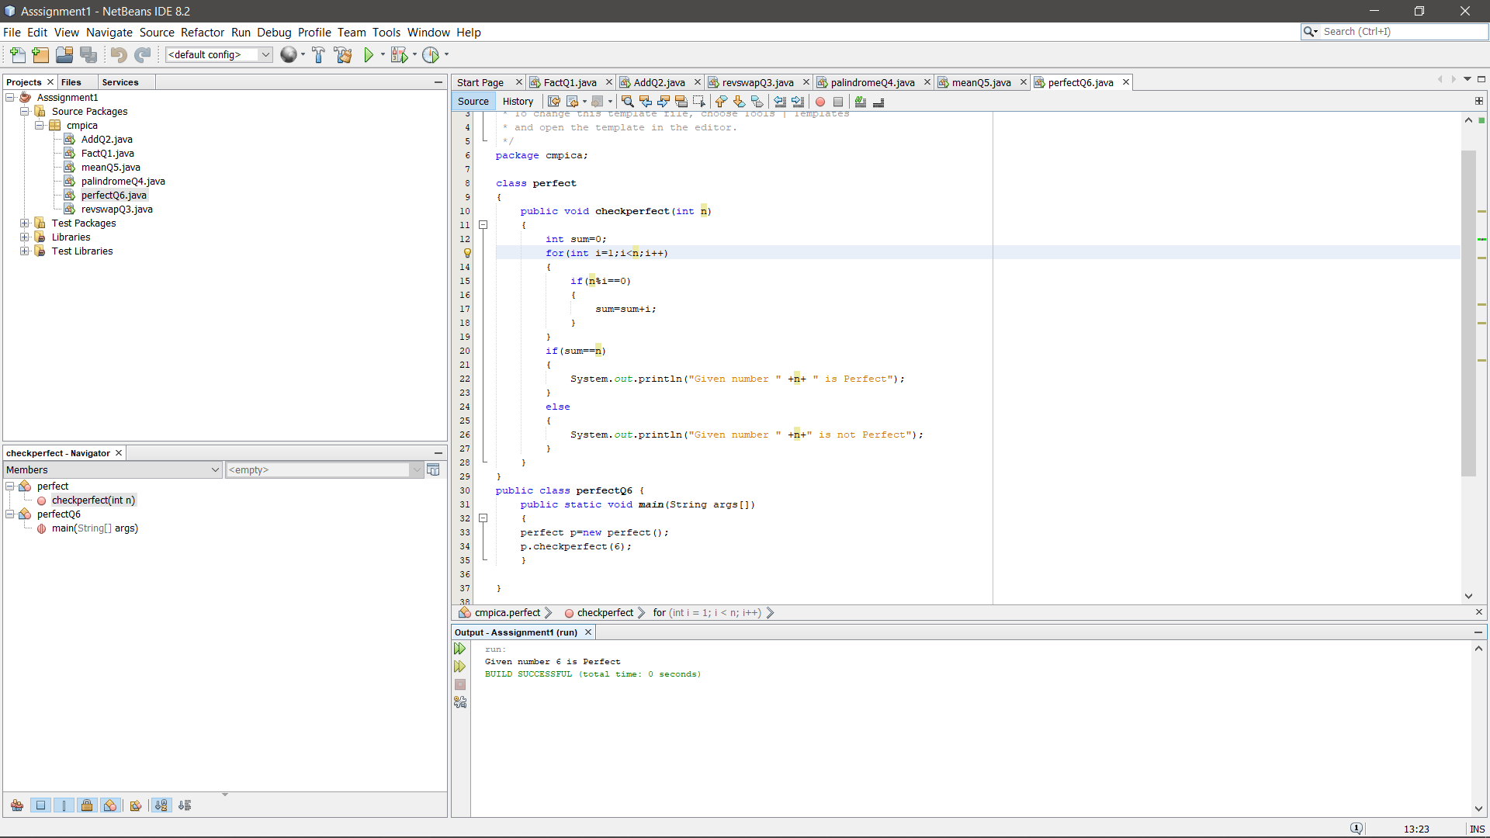

Q.7 Write a program to check whether a given number is Prime or not from given range.

package cmpica;

class prime

{

public void checkprime(int n)

{

int flag=0;

if(n<=1)

System.out.println("Number is Not a Prime Number.");

else

{

for(int i=2;i<n;i++)

{

if(n%2==0)

{

System.out.println("Number is not prime");

flag=1;

break;

}

}

if (flag==0)

{

System.out.println("Number is a prime number");

}

}

}

}

public class primeQ7 {

public static void main(String[] args) {

prime p=new prime();

p.checkprime(3);

}

}

OUTPUT:

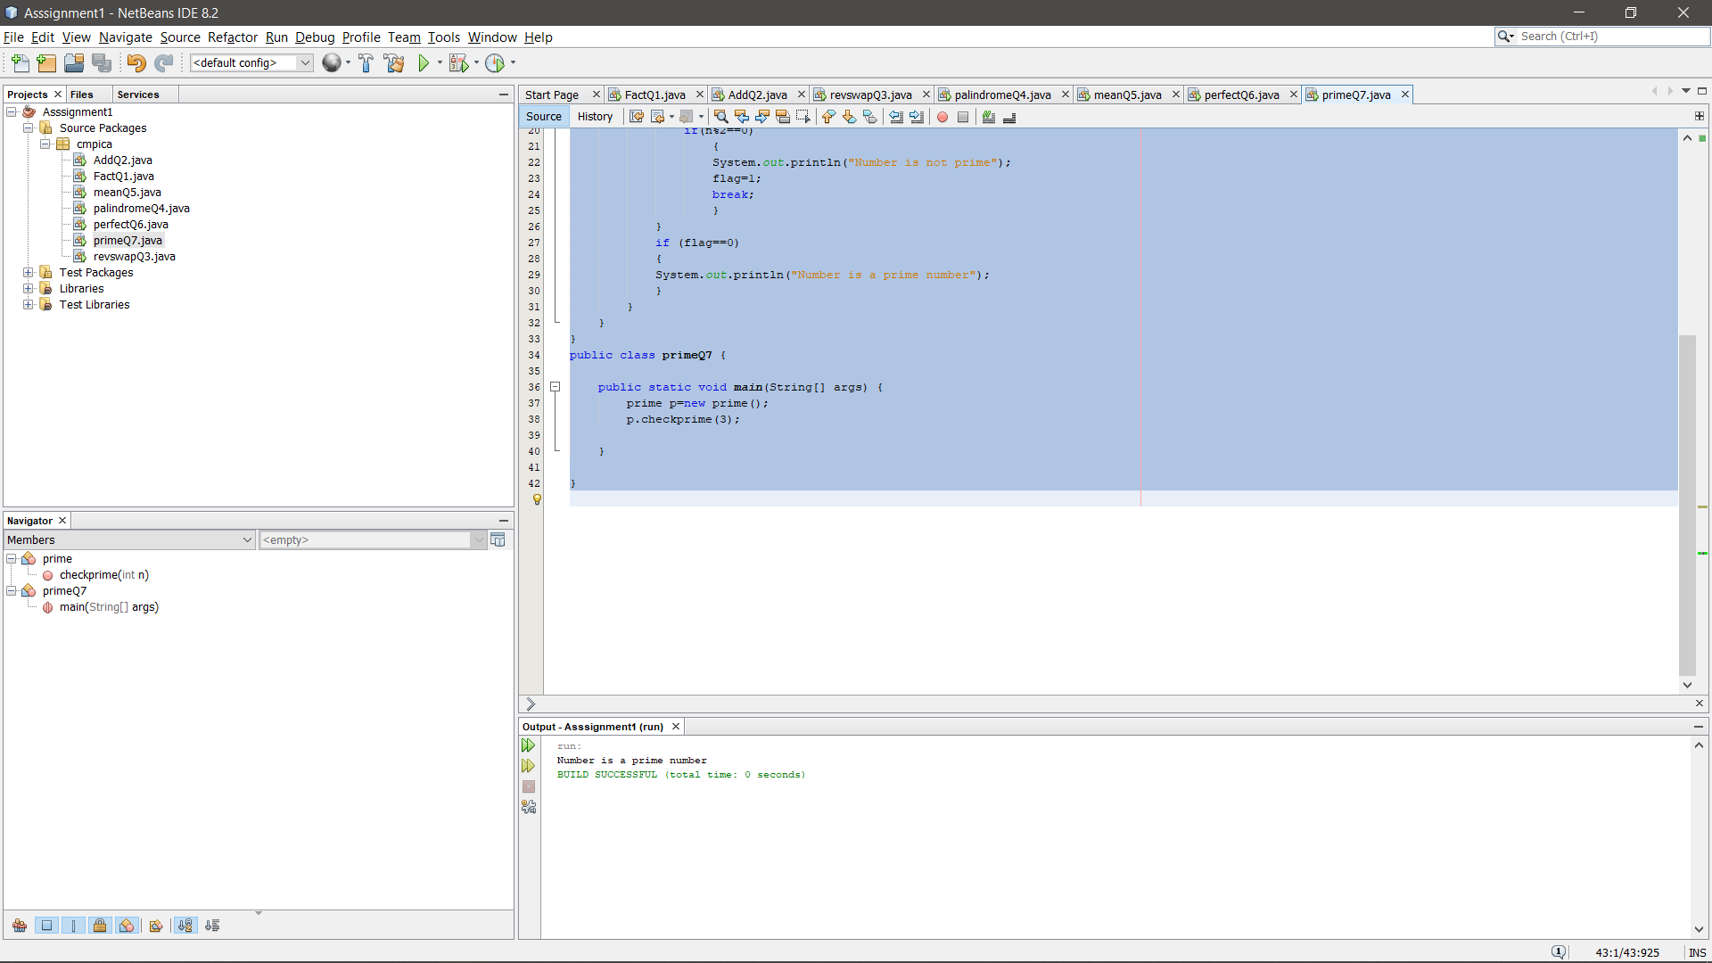

Q.8Write a program to check whether a given number is Armstrong or not from given range.

package cmpica;

class armstrong

{

public void checkarmstrong(int n)

{

int r,temp,sum=0;

temp=n;

while (n>0)

{

r=n%10;

sum=sum+(r*r*r);

n=n/10;

}

if (sum==temp)

{

System.out.println("Number Is Armstrong");

}

else

{

System.out.println("Number Is Not Armstrong");

}

}

}

public class armstrongQ8 {

public static void main(String args[])

{

armstrong a=new armstrong();

a.checkarmstrong(12); }

}

